|  |  |
| --- | --- |
|  | **DAYANANDA SAGAR UNIVERSITY**  Devarakaggalahalli, Harohalli  Kanakapura Road, Ramanagara - 562112, Karnataka, India |

**Smart India Hackathon**

**Women Safety Analytics– Protecting Women from safety threats**

**SafeSight**

By

**Sanmathi Y A ENG22CT0018**

**Neethu J ENG22CS0110**

**Sevanth Prabudh C H ENG22CS0157**

**Satwik Dinesh Walke ENG22AM0056**

**Anusri Rao ENG22CS0021**

**Nandini R ENG22CS0108**

**Under the supervision of**

**Dr Girisha G S Dr Basavaraj N Hiremath**

Chairperson, CSE Associate Professor, CSE

**SCHOOL OF ENGINEERING**

**DAYANANDA SAGAR UNIVERSITY**

**(2023-2024)**

**Problem Statement -1605**

The growing concern for the safety of women and the increase in crimes against women in various cities, highlight the need for advanced surveillance and analytical solutions to protect women from various possible threats. We need a promising approach to **address these issues through real-time threat detection software.** Detailed Description: By leveraging advanced analytics through real-time monitoring, Women Safety Analytics should create safer environments for women and assist law enforcement in effectively addressing and preventing crimes against women. The proactive **approach of detecting anomalies and generating alerts** can play a crucial role in enhancing public safety and fostering a secure atmosphere for women. Women safety analytics software **should continuously monitor the scene to count the number of men and women present**, **offering insights into gender distribution in specific locations and times. It** **should identify unusual patterns, such as a lone woman at night, unusual gestures and generates alerts to pre-empt potential incidents**. Advantages of the system by providing real-time monitoring and alerts, the system helps to create a safer environment for women**. Early detection enables law enforcement to intervene before situations escalate**. Continuous analysis provides valuable data to identify hotspots and trends, aiding in strategic planning for city safety Expected Solution: Women safety analytics should include the following functionalities **1. Person detection along with Gender Classification 2. Gender Distribution : Count the number of men and women present in the scene 3. Identifying a Lone Woman at Night time 4. Detection of a Woman Surrounded by Men 5. Recognizing SOS situation through gesture analytics 6. Identifying hotspots where incidents are more likely to occur, based on the past alerts.**

**abstract**

With the rising concerns over women's safety and the increasing incidence of crimes against women, there is an urgent need for advanced surveillance and analytical systems The Women Safety Analytics System proposes the development of a real-time threat detection system which is designed to enhance public safety and support law enforcement agencies in preventing and addressing crimes against women. The system utilizes CCTV cameras equipped with OpenCV, YOLO, and CNN technologies to perform continuous monitoring and analysis of the scene to identify people, classify gender, and count the number of men and women. The system also detects distress signals such as gestures, facial expressions, body language, and loud noises using Short Time Energy . When unusual or dangerous situations are identified—like a lone woman at night, aggressive body language, or loud shouting—the system sends immediate alerts to security personnel, enabling quick intervention. The system’s real-time monitoring aims to create safer environments for women by detecting and responding to potential threats swiftly.

**INTRODUCTION**

Women safety analytics leverages data and technology to enhance security and address safety threats faced by women. By analyzing data from sources such as crime reports, social media, and emergency calls, this approach helps identify patterns, assess risk areas, and implement targeted interventions. This proactive strategy not only improves response times but also helps in devising preventive measures to safeguard women in various environments.

In India, the integration of women safety analytics has been exemplified through initiatives like the ‘Nirbhaya’ Fund, which supports technology-driven safety projects. For example, in cities like Delhi, data analytics have been used to identify high-risk areas and deploy additional security measures, such as increased patrolling and surveillance systems. Mobile apps like "SafetyPin" further enhance safety by providing real-time alerts and safety ratings for neighborhoods, demonstrating how analytics can significantly improve women's safety in urban settings.

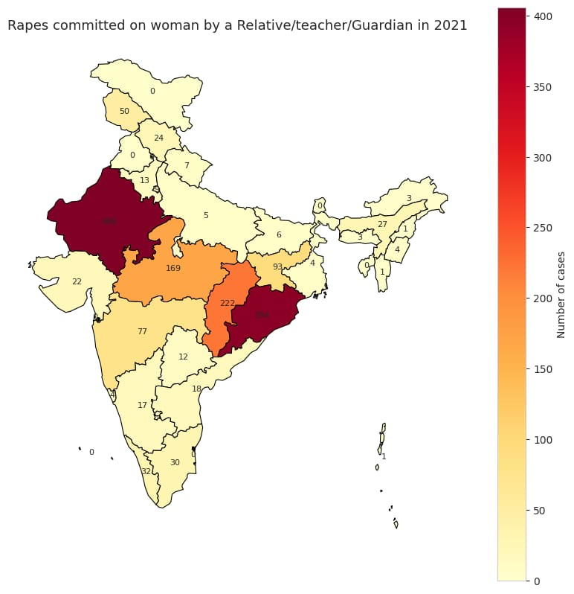

Figure 1.1 Rapes committed on women by a Relative/Teacher/Guardian

Figure 1.1 provides the estimated Rapes committed in India as reported by Statista in 2021. The chart also provides the idea of which state of India is in red zone and needs immediate action to be taken .

**Rape Case Analytics**

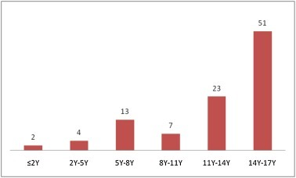

Figure 1.2 Rape cases in different age groups.

The Figure 1.2 provides the rape incidents occurred in different age groups of women, girls who are victims of such irresponsible behaviours

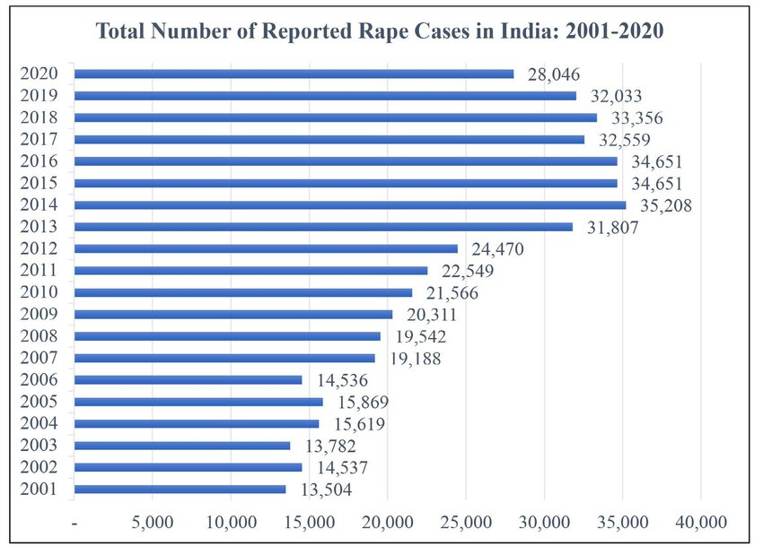

Figure 1.3 Reported Rape cases in India.

The Figure 1.3provides the analysis of the reported rape cases in India over the past two decades which is very concerning with growing technology we can be able avoid such incidences

The core functionalities of the Women Safety Analytics system include:

1. **Person Detection and Gender Classification**: Identifying and classifying individuals in the surveillance feed.
2. **Gender Distribution Analysis**: Counting the number of men and women present in the monitored area.
3. **Lone Woman Detection**: Identifying instances where a woman is alone at night.
4. **Detection of Encircled Women**: Recognizing situations where a woman is surrounded by multiple men.
5. **SOS Situation Recognition**: Analyzing gestures and expressions to detect distress signals and abnormal behavior.
6. **Hotspot Identification**: Analyzing data to pinpoint areas with a higher likelihood of incidents based on past alerts.

**The prototype model of Women Safety Analytics**

Opencv – Frame Work(in-built RTSP)

Path to YOLO

v

**Websocket**

To send safety signals to the authorithy and also the person in danger

Path to Websocket

Path to CNN

**YOLO + CNN**

Facial detection Gender Distribution, Gender Classification

**CNN+VAD**

Gesture recognition Expression recognition Voice recognition

Figure 2.1 Prototype model for women safety anaylsis working .

The Figure 2.1 provides the idea of the technologies used in the prototype model and their integration which enables us for predict and reduce the occurrence of rape and enables women safety across India.

**OpenCV:**

* For face detection and image preprocessing.
* To capture video frames from the CCTV camera ,can be done using RTSP (Real-Time Streaming Protocol) which is in-built in opencv

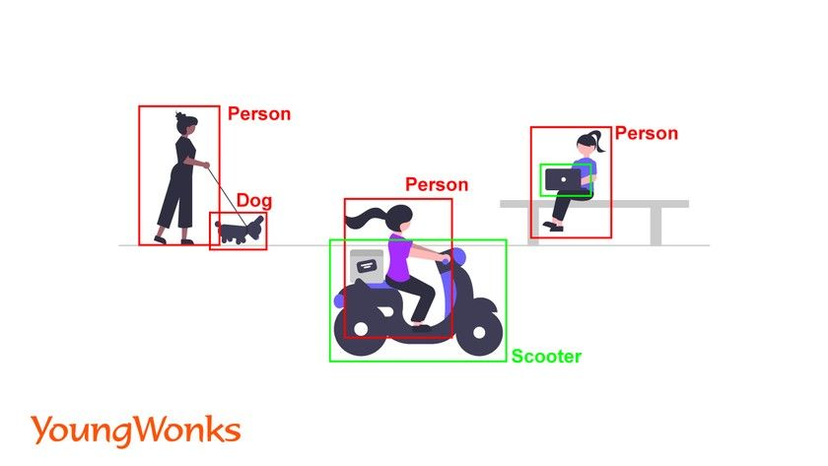

Figure 2.2 Object detection by opencv .

The Figure 2.2 provides the functioning of opencv which aids in image processing and providing frame for yolo from the cctv visuals in real time and it has inbuilt RTSP

**YOLO:**

* Using YOLO to detect people in each frame. YOLO will return **bounding boxes**, confidence scores, and class labels for each detected object
* Extract regions of interest (ROIs) corresponding to the detected people.
* Yolo being integrated is able count the number of people present.
* Resize and pre-process these ROIs to feed them into the CNN model for gender classification.

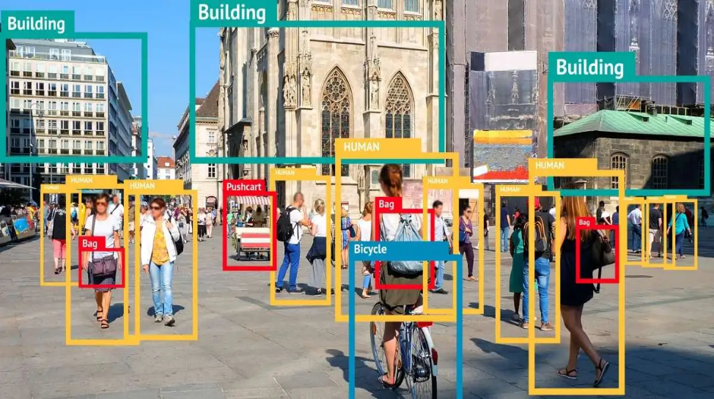The Figure 2.3 provides the working of yolo in real-time by extracting ROI’s and preparing bounding boxes which aids in gender identification

Figure 2.3 Functioning of Yolo.

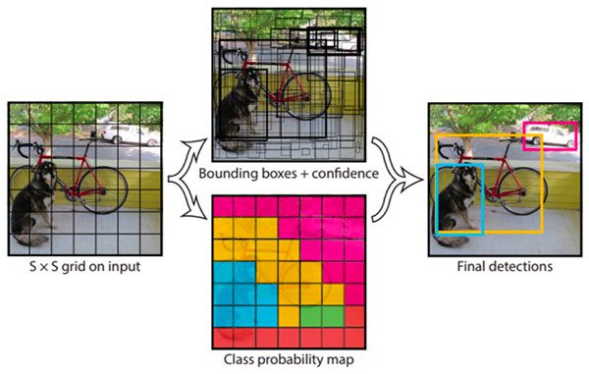

Figure 2.3.1working of yolo by creating bounding boxes.

The Figure 2.3.1 provides the functioning of yolo which enable sus identify the presence of objects an people present in the frame in real time

**CNN:**

* Use the pre-trained CNN model to classify the gender of each detected person.
* Integrate results with the bounding boxes from YOLO for analysis.
* Being trained in both gesture and expression recognition aids in analysis the situation in better terms.

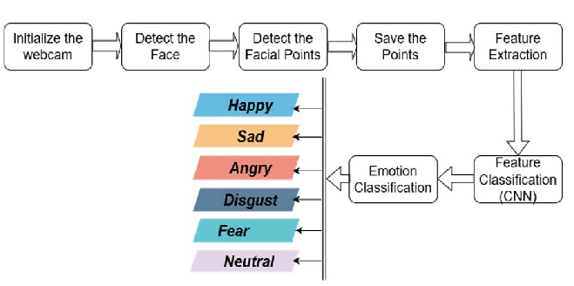

Fig 2.4 Expression analysis by CNN

**YOLO (You Only Look Once) + Gender Classification CNN:**

YOLO is a state-of-the-art object detection algorithm that detects people in real time with high speed and accuracy. After detecting people, a CNN (Convolutional Neural Network) can classify each detected person’s gender .

Both yolo and CNN can be integrated and used to predict both the class and location of objects in an image here location meaning place and class meaning the gender of the person.

Advantages: Fast, accurate, and suitable for real-time applications; works well with high-resolution CCTV footage.

**Implementation**: Use YOLO for person detection, crop the detected regions, and pass them through a gender classification CNN.

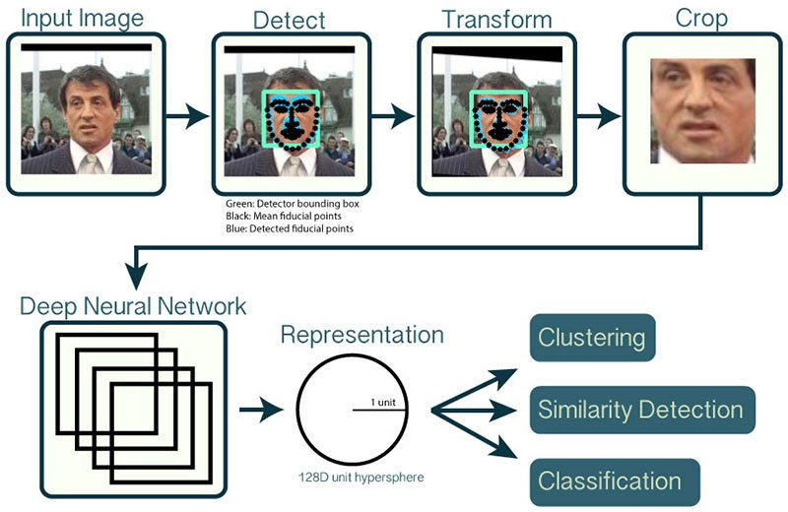

Figure 2.5 shows the working of yolo and cnn together efficiently

The Figure 2.5 enables us to understand the role of yolo and cnn in identification of the person and analysing the expression of the person which aids in analysing and determining the situation in case of violence.

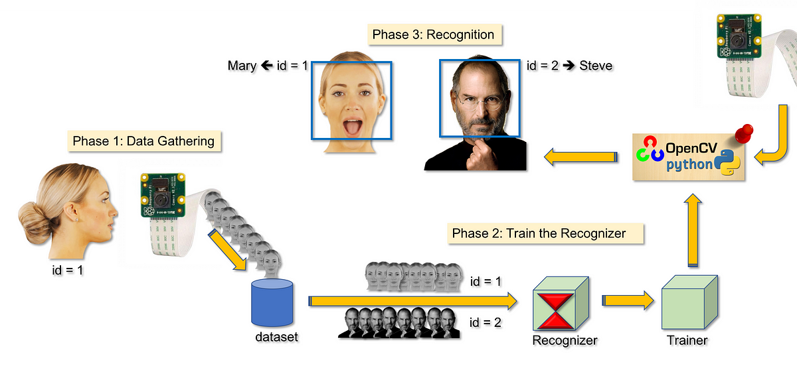

Figure 2.6 Matching and identifying the person with data

The Figure 2.6 provides the flowchart of the working of the model to identify the person present in the visuals in the cctv

**Short Time Energy (STE):**

* Neural networks, particularly Convolutional Neural Networks (CNNs) or Recurrent Neural Networks (RNNs), can be trained to recognize patterns in voice intensity across different contexts.
* **Short-Time Energy** is calculated by summing the squares of the amplitude values over short time frames (e.g., 20-30 milliseconds). It provides a measure of how intense or energetic the signal is within each frame.

**Web socket**:

* Web Sockets provide a full-duplex communication channel over a single, long-lived TCP connection. This method allows instant communication between the detection system and authorities.
* The surveillance system maintains a persistent WebSocket connection with the control center. Upon detection of an event, an alert message is sent instantly over this channel.

**Advantages:**

* Real-time, bidirectional communication.
* Low overhead compared to traditional HTTP requests.
* Ideal for continuously updating the status of a monitored area.

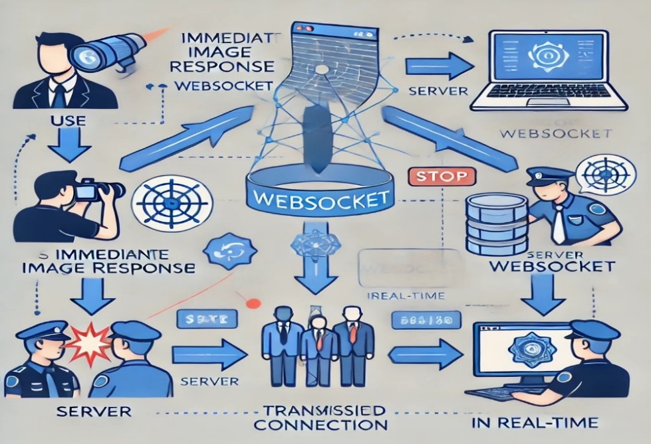

Figure 2.7 Working of websocket

The Figure.2.7 provides the flowchart of the model in case a threat is identified , the model sends an immediate signal to the security personnel to be ready to help the person in need via the websocket.

**Conclusion**

The Women Safety Analytics project represents a significant advancement in the realm of real-time threat detection and public safety. By integrating CCTV surveillance with cutting-edge technologies such as OpenCV, YOLO, CNN, and gesture recognition, this system offers a robust solution for enhancing women's safety in urban environments. The system’s ability to perform real-time person detection, gender classification, and anomaly detection ensures a proactive approach to preventing potential threats and addressing emergencies promptly.

The functionalities of the system, including gender distribution analysis, lone woman detection,provide comprehensive coverage of various scenarios that could endanger women. The incorporation of real-time alerts and notifications not only aids in immediate intervention by security personnel but also empowers individuals by allowing them to signal distress easily.

The model not only addresses the urgent need for enhanced safety mechanisms but also sets a precedent for future advancements in surveillance technology aimed at protecting vulnerable populations.

In summary, Women Safety Analytics stands as a pivotal step towards a safer and more secure environment for women, combining technological innovation with practical application to tackle real-world challenges.

**References**

* **OPEN CV MODEL FOR AGE AND GENDER DETECTION**
* [**https://medium.com/@wiembenghozzi/age-and-gender-detection-from-facial-images-8cca1c4f60ed**](https://medium.com/@wiembenghozzi/age-and-gender-detection-from-facial-images-8cca1c4f60ed)
* **Intelligent Video Surveillance System for Real Time Effective Human Action Recognition using Deep Learning Techniques**
* [**https://ieeexplore.ieee.org/document/10404670**](https://ieeexplore.ieee.org/document/10404670)
* **Accurate Face Annotations utilizing Deep CNN**
* [**https://ieeexplore.ieee.org/document/10182628**](https://ieeexplore.ieee.org/document/10182628)
* **Integrated Crowd Counting System Utilizing IoT Sensors, OpenCV and YOLO Models for Accurate People Density Estimation in Real-Time Environments**
* [**https://ieeexplore.ieee.org/document/10530804**](https://ieeexplore.ieee.org/document/10530804)
* **Face recognition algorithm based on open CV**
* [**https://ieeexplore.ieee.org/document/9639288**](https://ieeexplore.ieee.org/document/9639288)
* **Crimes in India**
* **https://public.tableau.com/app/profile/amarendrad/viz/CrimesinIndiaunderIndianPenalCodeIPC-2014/CrimesinIndia**